Part A: Analyzing Analogies

QUESTION 1--12
- 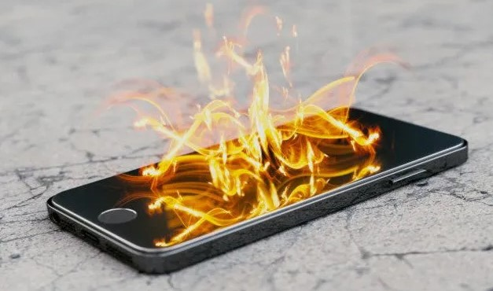
Why do some cell phone batteries explode? Consider the following passage about how that can happen from a news article in 2016:
"That’s what went wrong with the Galaxy Note 7: the separators were flawed and let the two electrodes touch.... Electrolytes aren’t very stable to begin with and the quick movement they facilitate also leads to instability. When there’s a lot of heat — whether through the two electrodes touching, or something as simple as it being too hot outside — it can make the electrolyte react with the other chemicals and create gas in a way that releases even more heat. Each time the chemicals react, the gases release more and more heat at a faster and faster rate. This creates an uncontrolled positive feedback loop called 'thermal runaway,' which can end in a fire.
This is why many phones shut down automatically when it’s hot. But there are other ways that batteries become explosive. They can also fail when they’re charged too much, or too fast.
Overcharging is like filling up a bucket with too much water. It doesn’t matter how slowly you go because if you pour in too much, the bucket will overflow. In the case of batteries, overcharging happens when too much lithium goes into the anode. This isn’t something you risk from keeping your phone plugged in all night — most batteries are designed to automatically prevent overcharging. Rather, it’s a manufacturer defect that can happen when the circuitry that prevents this from happening is faulty.
'The battery is like a rubber band', says Dan Steingart, a materials scientist at Princeton University. 'When you’re charging the battery, you’re stretching the rubber band; when you’re using it, you’re releasing it. Just like a rubber band can break if you stretch it too much, putting too much energy into one side will ruin the battery.'"
What is the target in Dan Steingart's analogy?
 | a. | empty buckets
 | b. | charged lithium ion batteries
 | c. | cell phones
 | d. | stretched rubber bands

QUESTION 2
- According to the analysis above, what is the proximate cause of cell phone battery fires?
 | a. | lithium's atomic structure
 | b. | overcharging the battery
 | c. | thermal runaway
 | d. | manufacturer's defects

QUESTION 3
- 
When did the ability to hear music evolve?
In 2014, headlines rang out, "Monkey-Human ancestor developed music skills 30 million years ago" based on research conducted by Vrije Universiteit Brussel faculty in Austria. Consider this passage:
“This kind of experiment is usually done by presenting monkeys with human speech,” co-author Ruth Sonnweber said. “Designing species-specific music-like stimuli may have helped the squirrel monkeys’ perception.” Through these reactions [defined as "head turns towards the loudspeaker of 45° or more" MM ed.], squirrel monkeys demonstrated that they in fact understand musical patterns, and also understand when they change, showing a clear response to music. This ability, central to language and music, therefore evolved at least 30 million years ago in the small and furry tree-dwelling primate that was the last common ancestor between humans and monkeys."
The basic structure of an analogy is three parts: If A is like B and B has property X, A probably has property X also, where A is the target and B is the source. The first step to answer the general question is to answer the more specific question: What are A, B, and X in this research?
In particular, what is the source in this argument from analogy?
 | a. | musical patterns
 | b. | the squirrel monkeys in the study
 | c. | human speech
 | d. | extinct tree-dwelling primates

QUESTION 4
- What is the trait of interest in this argument from analogy?
 | a. | whether monkeys turned their heads towards the speaker
 | b. | whether understanding musical patterns is a precursor to understanding speech
 | c. | whether the primates in question can recognize musical patterns
 | d. | whether tones were pitched high or low

QUESTION 5
- Does an enriched environment make it easier to learn complex tasks?

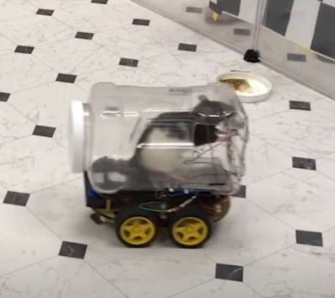
A news article from 2019 describes a study involving rat behavior:
"A bunch of rats have learned how to drive tiny vehicles around to pick up food. How did this unlikely scenario come around, you're no doubt asking? Well, for a surprisingly interesting reason, actually.
Researchers from the University of Richmond in Virginia used the vehicle-driving rodents to show that an enriched environment can improve cognitive function and help sharpen the ability to learn complex tasks. They also demonstrated that the mastery of a complicated skill can reduce levels of stress and help the rodents chill out.
“The findings that the animals housed in a complex environment had more efficient learning in the driving task confirms that the brain is a plastic organ that is molded by our experiences to some extent,” Dr Kelly Lambert, study author and professor of Behavioral Neuroscience at the University of Richmond, told IFLScience.
“I tell my students that they are accountable for what they do with their brains every day of their lives – more challenging and enriching lifestyles lead to more complex neural networks.”
What overall hypothesis did the study confirm?

 | a. | Students should be held accountable for what they do with their brains.
 | b. | Animals housed in a complex environment had more efficient learning in the driving task.
 | c. | The brain is a plastic organ that is molded by our experiences to some extent.
 | d. | A bunch of rats have learned how to drive tiny vehicles.

QUESTION 6
- What analogy does Dr. Lambert make on the basis of her research?
 | a. | Her students are like her lab rats: the more enriched their environments are the easier time they have learning complex tasks.
 | b. | The rats that lived in enriched environments learned to drive cars faster than those who did not.
 | c. | Rat brains are like human brains in that they are both easily stressed out.
 | d. | Rats are like humans in that they both enjoy learning complex tasks.

QUESTION 7
- Where do our economic reasoning patterns come from?
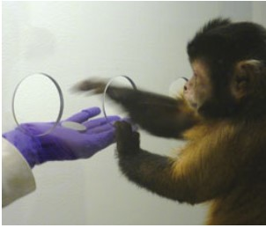
Consider the following study:
"Capuchins broke off the human line roughly 35 million years ago; as a result, they share many of our complicated cognitive strategies, yet they remain isolated from the linguistic, cultural, and technological systems that might corrupt human decision making. From the perspective of someone studying irrational economic biases, the monkeys offer an excellent means of distinguishing learned behaviors from natural ones. They provide, as Santos says, a 'really great window' into human behavior of old. In study after study in recent years, that window has shown Santos and her collaborators that capuchins indeed repeat many of the economic mistakes once considered unique to mankind — from loss aversion to the endowment effect to certain risk behaviors — suggesting that these irrational tendencies are a long-held, fundamental phenomenon.
'When you study humans it’s hard to get to the root of what makes us who we are,' says Santos, who will participate in the Presidential Symposium at the APS Annual Convention in May. 'If you look at the field of psychology over the last 20 years, you don’t find that humans are so smart. You find that our judgments are bad and that we’re biased and prejudiced — things we’re not really proud of, and that can seem pretty irrational. I realized there was no study of the origin of this stuff — no idea where the biases came from. I took that to be a bit of a puzzle.'
The first step toward solving this puzzle began in the early 2000s. Before Santos and Yale colleagues Keith Chen and Venkat Lakshminarayanan could test for irrational economic behavior in capuchin monkeys, they had to be sure the monkeys understood the concept of money at all. So the researchers designed a special 'monkey marketplace,' a separate cage accessible from the normal monkey living space, complete with open slots that enabled the animals to interact with experimenters. Then they issued the monkeys “wallets” filled with small, coin-like tokens. Finally they had two experimenters pose as traders, offering food through the slots in exchange for tokens.
As it turns out, the monkeys quickly mastered the rules of basic exchange. They learned to deposit a token into the outstretched hand of one trader and receive the piece of food being offered by the other hand. They learned to recognize a sale, purchasing more apples when the price dropped. In fact, Santos told an audience at a TED conference last July, it didn’t take long for the monkeys to reflect many of the same negative behaviors humans exhibit in the presence of money: Some stole tokens from their neighbors, and others, evidently averse to saving, spent their entire allowance in a flash."
What economic behavior(s) did the monkeys display that humans also display?

 | a. | monkeys could recognize sale prices
 | b. | some monkeys learned to steal while others were averse to saving
 | c. | monkeys displayed irrational behaviors like loss aversion and the endowment effect
 | d. | all of the above

QUESTION 8
- What overall hypothesis about human behavior did the study confirm?
 | a. | Humans and monkeys display no common behaviors when it comes to reasoning about money.
 | b. | All marketplace behaviors are acquired from interactions with the environment.
 | c. | Some marketplace behaviors are irrational and nothing to be proud of.
 | d. | Some marketplace behaviors are innate or inherited from our distant ancestors.

QUESTION 9
- What do the fox studies say?

Consider the following argument by analogy:
"A Soviet geneticist, Belyaev was interested in how animal domestication occurs — and in what happens biologically when the wild canine evolves into the mild-mannered dog. The thousands of fox fur farms stippling the Siberian countryside at the time were ideal grounds for his experiment. Belyaev started breeding especially docile foxes and observing the temperament of their pups. Within just three generations they were noticeably less fearful and aggressive toward people. By the fourth generation some pups would even approach their captors, wagging their tails like giddy retrievers. The animals were showing signs of friendliness toward humans. They'd been domesticated.

Duke anthropologist Brian Hare argues that humans unintentionally experienced a similar process that left us more cooperative than our now extinct human cousins, like Neanderthals and Denisovans. While Belyaev's foxes underwent artificial evolution through breeding, Hare and others believe that in Homo sapiens natural selection favored friendliness — that without realizing it we were self-domesticated by our own evolution, and that our more agreeable demeanor is responsible for our success and propagation across the planet."

What is the source in Brian Hare's argument by analogy?
For the source of the image above and a critique of Belyaev's study, see:
https://www.sciencenews.org/article/russian-foxes-tameness-domestication

 | a. | Neanderthals and Denisovans
 | b. | modern humans
 | c. | wild Siberian foxes
 | d. | Belyaev's domesticated foxes

QUESTION 10
- Hare continues by making further analogies:
“In his new book, Survival of the Friendliest: Understanding Our Origins and Rediscovering Our Common Humanity, Hare presents a thesis on why being more cooperative with those around us, and more willing to compromise, may have conferred survival advantages. … ‘When you look back in nature and see when a species or group of species underwent a major transition or succeeded in a new way, friendliness or an increase in cooperation are typically part of that story,’ says Hare. He cites the evolution of flowering plants, which evolved over 100 million years ago out of cooperation with pollinators. Dogs too were domesticated as amicability became adaptive. Wolves friendlier toward humans would've had a more reliable food source and a better chance of living on.
A major social milestone for humans was the cognitive revolution that took place between 40,000 and 90,000 years ago, when our creativity exploded into a gallery of tools, weapons, carvings, and cave drawings. Cooperation meant skills and knowledge could spread within and between groups of our hunter-gatherer ancestors like never before."
What are additional sources in these further analogies?
 | a. | hunters and gatherers: they both need tools and skills
 | b. | skills and knowledge: they both require cooperation to develop and spread
 | c. | tools, weapons, carvings, and cave drawings: they all underwent innovation thousands of years ago
 | d. | flowering plants and dogs: they both evolved through cooperation

QUESTION 11
- Is running hard on our knees?
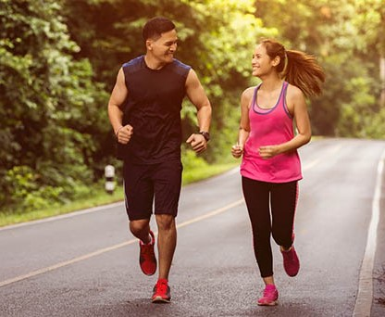
Consider this passage from an interview by Terry Gross with Daniel Leiberman on NPR:

"There's this kind of general idea out there that running is like driving your car too much — [that] it's wear and tear, and that running is highly stressful and it just wears away your cartilage, just like driving your car for a long period of time wears out your springs, for example. And that turns out not to be true. Study after study has shown that in terms of 'wear' — by which we really mean arthritis, degeneration of the cartilage in your joints — that people who run more are not more likely to get arthritis in their knees. In fact, they're actually slightly less likely to get arthritis, because using your cartilage, using your joints, using your muscles, strength, all the good benefits from physical activity actually turn out to be slightly protective."

What analogy does Leiberman reject in this passage?
 | a. | Cartilage is like muscle--both benefit from regular exercise.
 | b. | Arthritis is like degeneration--both involve cartilage in the joints.
 | c. | Running is like any other physical activity--one should consult a physician before undertaking an exercise regimen.
 | d. | Running is like driving a car too much--both inevitably lead to wear and tear on mechanical parts.

QUESTION 12
- What is Leiberman's conclusion?
 | a. | Non-runners are far more likely to develop arthritis in their knees than runners.
 | b. | Running confers a slightly protective benefit against developing arthritis in the knees.
 | c. | Running confers neither benefit nor harm to knee joints.
 | d. | Runners are more likely to develop arthritis in their knees than non-runners.

Part Ai

QUESTION 1
- Consider the following proof:
1. D v Q
2. D ⊃ P
3. ∼P ∴ Q
4. ∼D _____ _____
5. Q _____ _____

QUESTION 2
- Consider the following proof:
1. (M • N) ⊃ K
2. M
3. N ∴ K.
4. M • N ______ _______ ___________
5. K _______ _______ ____________

QUESTION 3
- Consider the following proof:
1. B • (C ⊃ D)
2. B ⊃ X
3. X ⊃ A ∴ A
4. B _______ ________
5. B ⊃ A _______ ________
6. A _______ ________

QUESTION 4
- Consider the following proof:
1. (P ⊃ Q) • (K ⊃ M)
2. P
3. ∼ M ∴ Q
4. P ∨ K _________ _________
5. Q ∨ M _________ _________
6. Q _________ _________

Part B

Diagnosis Bad Reasoning 11

Description | What are the fallacies?
Instructions | The following questions are based on the proposal of the Southern Nevada Water Authority (SNWA) to collect water from the Great Basin of Nevada and Utah by constructing a pipeline to pump water into Las Vegas. Started in 1989, here is an article about the project from 2009:  https://www.hcn.org/issues/41.17/vegas-forges-ahead-on-pipeline-plan  After decades of resistance, the controversial SNWA pipeline project has officially shelved in 2020:  https://news3lv.com/news/local/southern-nevada-water-authority-votes-to-kill-groundwater-pipeline-project

QUESTION 1
- Identify the fallacy in this reasoning:
"So in conclusion, I would like to urge that the Southern Nevada Water Authority proposal be suspended indefinitely. Evidence does show that the collection of groundwater from the targeted valleys to divert to Las Vegas will serve up to 1.5 million people. But look at the tiny springsnails organisms that are able to thrive in the shelf areas at the sides of brackish Badwater Spring and other springs in the Great Basin. These fragile and vulnerable creatures are able to survive where humans could not, at the lowest point in the United States. It's not a fair fight, man vs. snail. Don't these little guys deserve our protection even if it means fewer people can live in Las Vegas?" [For even more back-story on the snails: http://www.hcn.org/issues/41.17].
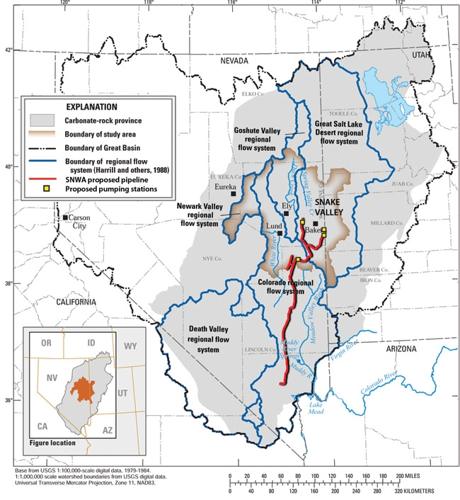
 | a. | appeal to ignorance
 | b. | appeal to pity
 | c. | ad hominem circumstantial
 | d. | no fallacy

QUESTION 2
- Identify the fallacies in this reasoning:
"The business interests of Las Vegas, the casinos, developers, grocers and convenience store owners, etc., are not breaking any law by demanding that this water be diverted their way. They are just doing what comes naturally to humans. And how can you complain about that? Surely doing whatever comes naturally is not going to be against the law."
 | a. | begging the question & equivocation
 | b. | appeal to fear & bandwagon
 | c. | appeal to pity & inconsistent premises
 | d. | no fallacy

QUESTION 3
- Identify the fallacy in this argument:
"This project will bring in millions of dollars to the Great Basin area, in general, and to the municipality of Las Vegas, in particular. Any project that benefits some businesses ought to be supported by all businesses. Business leaders need to stick together! Businesses that oppose the project do not deserve to stay open in Las Vegas."
 | a. | slippery slope
 | b. | peer pressure
 | c. | stereotype
 | d. | prejudice

QUESTION 4
- Identify the fallacy in this reasoning:
"The most important point here is that folks in Las Vegas absolutely need the water. Current residents are having kids and want them to stay close and new folks want to move to the desert. If we don't go ahead with the Great Basin project the city will dry up, businesses will close, hotels will shut down, folks will move away, and Las Vegas will become a ghost town."
 | a. | slippery slope
 | b. | appeal to pity
 | c. | bias
 | d. | no fallacy

QUESTION 5
- Identify the fallacy in this reasoning:
"Just think of the monument to human ingenuity that this water project will be. Humans will have potable water at their fingertips without erecting huge and energy hungry desalinization plants to treat surface water. Yes it will exact a toll on some areas. But we will get fantastic value for dollar from this monumental project because, when finished, it will be a major technological achievement worth every penny."
 | a. | begging the question
 | b. | appeal to fear
 | c. | appeal to pity
 | d. | no fallacy

QUESTION 6
- Identify the fallacy in this reasoning:
"The only people who oppose the Great Basin project are crunchy-granola nuts who think conserving natural resources is more important than urban developments people actually need. If Las Vegas needs water, then the people of Las Vegas need water. Draining the basin will not lead to any problems - draining the basin will only lead to progress!"
 | a. | ad hominem
 | b. | wishful thinking
 | c. | begging the question
 | d. | all of the above

QUESTION 7
- Identify the fallacy in this argument:
"This project will bring in millions of dollars to the Great Basin area, in general, and to the municipality of Las Vegas, in particular. So just think of the huge wealth that the pumping station project is going to bring to your small contracting business in Utah! How could you oppose it? Of course you should support it."
 | a. | slippery slope
 | b. | fallacy of composition
 | c. | begging the question
 | d. | fallacy of division

QUESTION 8
- Identify the fallacy in this reasoning:
“Three years ago, the seven states that draw water from the Colorado river negotiated a set of ground rules for how to share shortages if Lake Mead and Lake Powell, the river's two main reservoirs, continue to go down. When the water level drops below 1,075 feet, the first round of shared shortages will kick in on the renewed series of negotiations between the seven states. At this point, Las Vegas will be in a state of emergency such that Mulroy, director of the Southern Nevada Water Authority, says that they will be forced to launch construction on the groundwater project. Since the levels of Lake Mead are currently at 1,093 feet, it follows that the Great Basin project will probably be initiated, especially if the present drought continues.”
 | a. | fallacy of inconsistent premises
 | b. | appeal to fear
 | c. | begging the question
 | d. | no fallacy

QUESTION 9
- Identify the fallacy in this reasoning:
“Don Sada, in his High Country News article, ‘Silenced Springs?’ makes the following argument: ‘Humans must make use of water and other resources to survive. The problem is we have a penchant for using these resources to depletion. The challenge is to use them in a sustainable manner. Sustainable is an overused word, but there's just no good substitute for it. ...’ (p. 18). Although he argues that humans tend to use things up, he also says we have the power to use water and other resources in a sustainable way. Therefore, questions like whether or not to approve the Great Basin water project need not even arise because the issue is not what to do about our needs for resources and the uncontrolled growth of population centers in deserts. Rather, the issue is how to live without having to ask ourselves such approval questions by expecting humans to only use resources in a sustainable manner.”
 | a. | inconsistent premises & begging the question
 | b. | fallacies of division & composition
 | c. | slippery slope & appeal to pity
 | d. | no fallacy

QUESTION 10
- Identify the fallacy in this reasoning:
"If you go ahead with this pipeline project, it will harm the interconnected web work of passages tying the water systems of the Great Basin together. I know this on the basis of extensive hydrologic tests of the area published in refereed scientific journals. Further evidence can be seen in results of similar drainage projects in other regions where there has been subsidence and loss of groundwater needed for important vegetation and native animal life. If the Southern Nevada Water Authority goes ahead with this project, the region’s ecosystems, large and small, will most likely suffer as a result in a similar fashion."
 | a. | appeal to pity or sympathy
 | b. | scare tactic
 | c. | slippery slope
 | d. | no fallacy

Part C: Mill's Methods

QUESTION 1
- The Environmental Defense Fund lists nine ways by which we know humans are the cause of climate change. How is Mill’s Method of Concomitant Variations used to argue that global warming is caused by human activity?
 | a. | They point out that the more sea temperatures rise the more greenhouse gases like CO2 are emitted into the atmosphere.
 | b. | They point to a correlation between how CO2 emissions from human activity have increased and how annual average temperatures of the globe have increased.
 | c. | They remind us that global temperature increases and sea level rises are greater concerns in coastal cities than in the midlands.
 | d. | Since there are many reasons why global temperatures are on the rise this list is only a partial representation of all possible causes.

QUESTION 2
- "Most Americans recognize climate change, but some are still unsure about its causes. Tens of thousands of scientists in more than a hundred nations have amassed an overwhelming amount of evidence pointing to a clear conclusion: Humans are the main cause. We're the ones who burn fossil fuels, produce livestock and clear trees, increasing the amount of heat-trapping gases in the atmosphere.It's like the smoking-cancer link. No one questions the link between smoking and cancer, because the science was settled in the 1960s after more than 50 years of research. We can think of the state of human activities and climate change as no different than smoking and cancer. In fact, we are as confident that humans cause climate change as we are that smoking causes cancer."
What is the conclusion of this argument from analogy?

 | a. | There is a causal connection between smoking and getting cancer.
 | b. | The causal connection between human activities and climate change is just as strong as the causal connection between smoking and cancer.
 | c. | There is a causal connection between human activities and climate change.
 | d. | Burning fossil fuels and clearing forests both release heat-trapping gases in the air.

QUESTION 3
- In June 2015, scientists in the journal Nature reported that updating current climate models in light of new data suggest that global warming did not "take a break" during the first decade of the twenty-first century:
"The analysis follows a raft of papers that seek to explain why global temperatures seemed to level off around the turn of the millennium. NOAA's updated temperature record still shows cooler observed conditions than those projected by most climate models for the same period. But Karl says that the warming trend is clear up to the end of 2014. That holds true even if researchers choose 1998, which saw extreme heat associated with an El Niño weather pattern in the tropical Pacific Ocean, as the starting point for such an analysis."
What is the conclusion of this report?

 | a. | Scientists still do not know why the increase in global temperatures appeared to level off during the first decade of the twenty-first century.
 | b. | Global warming is a myth as evidenced by the fact that global temperatures started to cool down during the first decade of the twenty-first century.
 | c. | There are no foolproof methods for measuring global temperature changes over time.
 | d. | Although many scientists thought there was an apparent "hiatus" in global warming at the outset of the twenty-first century, improved data suggest that global temperatures rose from the late nineties until 2014.

QUESTION 4
- Lin and Li have studied the effect of carbon taxes in particular countries in the EU and presented their findings in this article: Lin, Boqiang & Li, Xuehui, 2011. "The effect of carbon tax on per capita CO2 emissions," Energy Policy, Elsevier, vol. 39(9), pages 5137-5146, September.
Here are two excerpts from their article in Energy Policy. (These are long extracts because the paper is behind a pay wall but you have Carlson Library access so you can "go behind the wall" to read the entire paper.)
"Based on the results of existing studies, we find it is still controversial as to the impact of carbon tax on international competitiveness of the industries, or the influences of tax exemption on the mitigation of different industries. Besides, most of the researches on carbon tax have been mainly based on simulation in different scenarios; only few of the existing studies have carried out empirical analysis on the effects of carbon tax. Therefore, in this article, we adopt the difference-in-difference method to estimate the real effects of carbon tax in order to provide more experiences for countries that are to levy the carbon tax. ...
The difference-in-difference approach identifies the treatment effects of a policy from two angles, the cross-sectional difference and the time-series difference. As an exogenous variable, the policy’s variation would inevitably change the external conditions of groups including the individuals, enterprises and the countries, thereby leading to fluctuations of these groups around time t. Further, the groups that are influenced are called treatment groups, and those that are not influenced are control groups. The significant changes in emissions difference between the two groups after time t implies the effectiveness of the policy (see Fig.1.):"
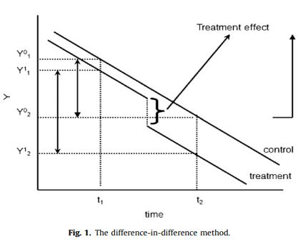
What is the causal issue at the heart of Lin and Li's research?
 | a. | Do industries cause the most carbon emissions?
 | b. | Do carbon taxes cause global warming to accelerate?
 | c. | Do carbon taxes cause emissions to go down?
 | d. | Do carbon taxes cause industries to become inefficient?

QUESTION 5
- Here is their conclusion as represented in their abstract:
"As the most efficient market-based mitigation instrument, carbon tax is highly recommended by economists and international organizations. Countries like Denmark, Finland, Sweden, Netherlands and Norway were the first adopters of carbon tax and as such, research on the impacts and problems of carbon tax implementation in these countries will provide great practical significance as well as caution for countries that are to levy the tax. Different from the existing studies that adopt the model simulation approaches, in this article, we comprehensively estimate the real mitigation effects of the five north European countries by employing the method of difference-in-difference (DID). The results indicate that carbon tax in Finland imposes a significant and negative impact on the growth of its per capita CO2 emissions. Meanwhile, the effects of carbon tax in Denmark, Sweden and Netherlands are negative but not significant. The mitigation effects of carbon tax are weakened due to the tax exemption policies on certain energy intensive industries in these countries."
How do Lin and Li adapt Mill's Method of Difference to study the varying effects of a carbon tax on CO2 emissions in different countries?
 | a. | While some European countries tax carbon usage some countries allow for a greater number of exemptions for industries and individuals than others.
 | b. | The only way to effectively tax carbon usage is to make sure there are exemptions and ways to offset emissions by undertaking projects elsewhere.
 | c. | The only way to effectively tax carbon usage is to restrict the number of exemptions available to industries and individuals.
 | d. | Countries who tax carbon and do not allow exemptions, such as Finland, have reduced their CO2 emissions, suggesting that carbon tax legislation without exemptions was causally more effective than a carbon tax with exemptions.

QUESTION 6
- How can we use Mill’s Method of Agreement to determine whether there is consensus among experts about whether global warming is a real threat?

 | a. | Survey folks leaving a hotel hosting a climate science conference to see how many think climate change is a real threat.
 | b. | Post the question in a blog post and see how many scientists agree in the comments that global warming is real.
 | c. | Call in to a radio show and challenge members of the audience to call in if they’re a scientist who thinks global warming is real.
 | d. | Look for a variety of scientists, from around the world, who share expertise in climate science in common and see whether they agree that global warming is an imminent threat.

QUESTION 7
- How do climate change skeptics use Mill’s Method of Residues to argue that human activity does not play a significant role in global warming trends?
 | a. | If the climate is so far gone that the best we can hope for is to slow global warming down somehow, why bother?
 | b. | The only reason scientists want global warming to be real is so they can continue to get research funding into how to avert impending climate changes.
 | c. | If there’s been an uptick in extreme weather events it will only be visible from an aggregate perspective; any individual disaster could have happened at any time.
 | d. | After industry, agriculture, and personal CO2 emissions are accounted for there are still trends that cannot be explained: something else must be causing the recent uptick in extreme weather events.

QUESTION 8
- While some believe climate change is not a problem to be solved, private companies are selling insurance policies to farmers that also help forecast adverse weather events:
“By attempting to provide that information, the Climate Corporation hopes to transform the weather business, so long the province of guesswork and desire, into a system driven solely by numbers. And there are a lot of numbers. Company scientists process fifty terabytes of weather information every day, roughly the equivalent of a hundred thousand movies or ten million songs. The data include eight years’ worth of soil, moisture, and precipitation records for each of the twenty-nine million farm fields in the U.S. In addition, the algorithm divides the country into nearly half a million plots, then generates ten thousand daily weather scenarios for each of them. This information is used to create individualized insurance policies for corn, soybean, and wheat farmers covering major perils like drought, heat stress, and the risk of an early freeze. When data show that a field is too wet, for instance, or that hot nights will interfere with the growth of a crop, an insured farmer simply gets a check. No claims, forms, adjusters, or negotiations are required.” http://www.newyorker.com/magazine/2013/11/11/climate-by-numbers
If the climate does change rapidly in the near future, and we have the data and algorithms necessary to model how global trends affect local regions, new jobs will be created in weather forecasting and big data.
What would you have to believe to work in this growing field?

 | a. | Each particular farm is so unique, like snowflakes, so there is no way big data strategies can help predict outcomes at the local level.
 | b. | As the frequency of adverse weather events goes up, farmers will need to insure their crops against the vagaries of increasing drought, flood, or freezing conditions.
 | c. | Only those farmers who have lost everything understand why insurance is important but only those who haven’t lost everything have anything left to insure.
 | d. | If a farmer does not believe that global warming is happening, then their farm will not be affected by droughts, floods, or uncharacteristic temperature fluctuations.

QUESTION 9
- Consider the abstract to the paper, “On the causal structure between CO2 and global temperature” by Adolf Stips, Diego Macias, Clare Coughlan, Elisa Garcia-Gorriz & X. San Liang from February 2016:
"We use a newly developed technique that is based on the information flow concept to investigate the causal structure between the global radiative forcing and the annual global mean surface temperature anomalies (GMTA) since 1850. Our study unambiguously shows one-way causality between the total Greenhouse Gases and GMTA. Specifically, it is confirmed that the former, especially CO2, are the main causal drivers of the recent warming. A significant but smaller information flow comes from aerosol direct and indirect forcing and on short time periods, volcanic forcings. In contrast the causality contribution from natural forcings (solar irradiance and volcanic forcing) to the long term trend is not significant. The spatial explicit analysis reveals that the anthropogenic forcing fingerprint is significantly regionally varying in both hemispheres. On paleoclimate time scales, however, the cause-effect direction is reversed: temperature changes cause subsequent CO2/CH4 changes."
What is the conclusion of this paper?
 | a. | Natural causes, like volcanic activity and solar irradiance, are causally responsible for global mean surface temperature anomalies.
 | b. | Aerosols are not a significant cause of global mean surface temperature anomalies (GMTA) since 1850.
 | c. | There is a clear causal connection between CO2 emissions and an increase in global mean surface temperature anomalies (GMTA) since 1850.
 | d. | Both hemispheres exhibit regional variations in CO2 emissions and surface temperature anomalies.

QUESTION 10
- What do these authors mean when they say that the cause-effect direction is reversed on paleoclimate time scales?
 | a. | We don't know whether increased CO2 causes increased global temperatures or the other way around.
 | b. | Some hemispheric regions are immune to climate change on a paleoclimate time scale.
 | c. | In the short term increased CO2 causes increased temperatures but over the long term temperature increases cause even more Greenhouse Gases to be released.
 | d. | As the planet gets warmer it causes the amount of Greenhouse Gases emitted to go down.

Part D: Computing the Odds

QUESTION 1
- The first two problems are adapted from Finite Mathematics for the Managerial, Life, and Social Sciences by Soo T. Tan: "According to a study of 100 drivers in metropolitan Washington D. C., whose cars were equipped with cameras with sensors, the distractions, and the number of incidents (crashes, near crashes, and situations that require an evasive maneuver after the driver was distracted) caused by these distractions are as follows:
Distraction: Incidents
Cell phone: 687
Passenger: 378
Something in car: 194
Vehicle: 163
Personal hygiene: 133
Eating: 134
Something outside car: 111
Talking/singing: 111
Other: 89
Total:2,000
If an incident caused by a distraction is picked as random, what is the probability that it was caused by a cellphone?"
 | a. | fifty-fifty
 | b. | one out of ten
 | c. | one out of three
 | d. | two to one

QUESTION 2
- If an incident caused by a distraction is picked at random, what is the probability it was caused by something other than a passenger or something in the car?
 | a. | 29%
 | b. | 50%
 | c. | 71%
 | d. | 81%

QUESTION 3
- Consider the following chart for the next two questions:
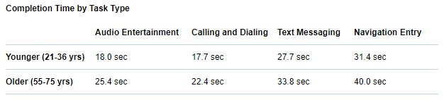
Which of the following is NOT one of the inferences we can draw based on the data in this chart?
 | a. | Older drivers spend more time texting behind the wheel than younger drivers.
 | b. | Using in-vehicle navigation entry systems is the distraction task that takes the longest for all drivers.
 | c. | When older drivers text while driving it takes them longer to complete that task than younger drivers.
 | d. | A young driver takes longer to text than it takes an older person to use the audio system.

QUESTION 4
- "The complex design of the technology created increased visual and cognitive demand for older drivers. For example, some systems included multiple menus and cumbersome voice command functions that significantly reduced older drivers' ability to easily complete seemingly simple tasks.
Specific design changes to in-vehicle infotainment systems, like improving voice-command technology, simplifying software menus, removing complex center console controls, and positioning system controls to allow drivers to keep their eyes on the road, would better meet the needs of older adults and make the systems safer for all drivers.
'This is a design problem, not an age problem,' said Jake Nelson, AAA director of traffic safety advocacy and research. 'Designing systems to meet the safety and comfort needs of aging drivers would benefit all of us today, and for years to come.'"
https://newsroom.aaa.com/tag/foundation-for-traffic-safety/
What is the conclusion?
 | a. | Older drivers take longer to complete tasks than younger people.
 | b. | In-vehicle infotainment systems are a safety-hazard for all people.
 | c. | An improvement to in-vehicle systems navigation would benefit everyone, especially older drivers.
 | d. | Older people need specially designed in-vehicle systems that meet their unique needs as drivers.

QUESTION 5
- "Of particular interest is the concordance (or lack thereof) between attitudes toward risky driving and self-reported behaviors. Often there is also a concordance between perceived risk of arrest and/or social approval. For example, the public regards drinking and driving as extremely dangerous, and people rarely report engaging in this behavior. On the other hand, speeding is regarded as the least dangerous of the driving activities in the survey and the most commonly cited self-reported risky driving behavior. There is a stark contrast between the public's attitudes toward cellphone use and self-reported behaviors. Many drivers noted the serious dangers associated with holding and talking on cellphones while driving, while also admitting to having done so in the past month."
https://aaafoundation.org/2018-traffic-safety-culture-index/
What is the conclusion of this passage?
 | a. | People freely admit to drinking and driving even though they acknowledge that it is dangerous.
 | b. | People do not freely admit to drinking and driving and do not acknowledge that it is dangerous.
 | c. | People believe speeding is a very risky driving behavior but they commonly admit to speeding.
 | d. | People's behaviors do not always align with their beliefs about how dangerous an activity is especially when it comes to using cellphones while driving.

QUESTION 6
- The following three problems are based on Figure 1 and Figure 2 and their data below taken from "Young Drivers Report the Highest Level of Phone Involvement in Crash or Near-Crash Incidences." Traffic Safety Facts (April 2012):
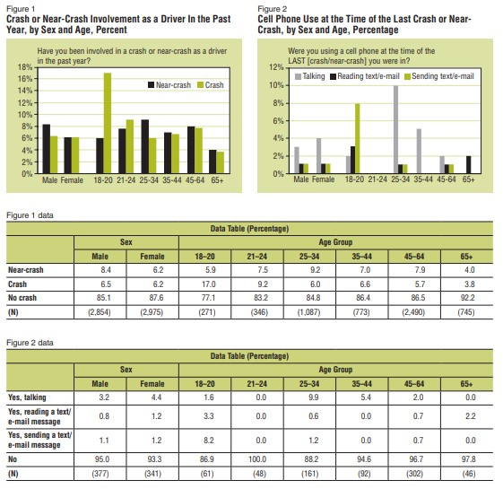
Which of the following is NOT one of the inferences supported by this data?
 | a. | The majority of respondents reported having been in no crash.
 | b. | Men have slightly more crash or near-crash incidences than women (15% versus 12%, respectively).
 | c. | Young drivers 18 to 20 have the highest incidence of crash or near-crash experience (23%) compared to all other age groups, and drivers 65 and older have the lowest (8%).
 | d. | Young drivers 21-24 report using a cell phone at the time of their last crash at a rate of 13%.

QUESTION 7
- If you were a young driver age 21-24 included in this survey, there's a 17% chance that you were in a crash or near crash in the last year. If you were an older driver age 45-64 included in this survey, there's a 14% that you were in a crash or near crash in the last year. Does it follow that individuals in both age groups have similar probabilities of being in a crash or near crash in the coming year?
 | a. | yes because 17% is not that much bigger than 14%
 | b. | yes but only if we define "similar probabilities " roughly as 10-20%
 | c. | no because 2,490 older drivers age 45-64 were in the survey but only 346 young drivers age 21-24
 | d. | no because 45-64 is a bigger age gap than 21-24 years old

QUESTION 8
- More people 18-20 years old reported sending texts at the time of the last crash or near crash they were in than any other age group (8.2%) while more 25-34 years old respondents reported talking on their cell phone during their last crash or near crash (9.9%). Does this mean that being distracted by cell phone use was a bigger problem for 25-34 years old respondents than any other age group?
 | a. | yes, because 9.9% is a bigger number than 8.2%
 | b. | no, because 25-34 is a bigger age gap than 18-20 years old
 | c. | yes, because 25-34 is a bigger age gap than 18-20 years old
 | d. | no because "distracted by cell phone use" must include talking, reading, and sending texts

QUESTION 9
- Are the following statistics compatible?
I. The National Highway Traffic Safety Administration and the Virginia Tech Transportation Institute say that most crashes and near-crashes are the result of inattentive driving.
II. While many car accidents are the result of distracted driving, more people die from drunk driving. According to the U.S. Department of Transportation, almost 30 people died every day in drunk driving crashes in 2017, one person every 48 minutes.
Source: https://www.freep.com/story/money/business/2019/04/16/distracted-driving-statistics/3449038002/
Is it possible for both I and II to be true at the same time?
 | a. | no: only one statistic may be true
 | b. | yes because the majority of crashes and near-crashes are non-fatal
 | c. | no because either drunk driving or inattentive driving is the leading cause of vehicular fatality
 | d. | yes because the minority of crashes and near-crashes are the result of inattentive driving

QUESTION 10
- What causal connection might there be between the first set of statistics and the second?
I. The majority of Americans (71%) admit they use their phones while driving, mostly to talk (93%) and dial (74%). But over half of Americans say they engage in activities that take their eyes off the road for even longer, like sending texts (60%) and checking notifications (56%).
II. Drivers identify using a phone as the number one distraction behind the wheel (43%), far surpassing children (11%), other passengers (9%), and changing the GPS (8%) or music (5%).
Source: https://www.volvocars.com/us/about/distracted-driving
 | a. | Drivers know phone use is the number one distraction because they are distracted by their phones while driving.
 | b. | Drivers know phone use is the number one distraction because they refuse to let their phones distract them while driving.
 | c. | Drivers do not realize phone use is the number one distraction because they refuse to let themselves be distracted by the phones while driving.
 | d. | Drivers do not realize phone use is the number one distraction because they are distracted by their phones while driving.

